**FLIGHT FARE PRICE PREDICTION USING DATA**

**SCIENCE**

A Project-II Report

Submitted in partial fulfillment of requirement of the

Degree of

**BACHELOR OF TECHNOLOGY in COMPUTER SCIENCE & ENGINEERING**

BY

**Ishita Nigam (EN18CS301112)**

**Luckyraj Singh Bais (EN19CS3L1011)**

**Hritik Shrivastava (EN18CS301102)**

Under the Guidance of

**Dr. Ratnesh Litoriya**



**Department of Computer Science & Engineering**

**Faculty of Engineering**

**MEDI-CAPS UNIVERSITY, INDORE- 453331**

**JAN-JUNE 2022**

**FLIGHT FARE PRICE PREDICTION USING DATA**

**SCIENCE**

A Project-II Report

Submitted in partial fulfillment of requirement of the

Degree of

**BACHELOR OF TECHNOLOGY in COMPUTER SCIENCE & ENGINEERING**

BY

**Ishita Nigam (EN18CS301112)**

**Luckyraj Singh Bais (EN19CS3L1011)**

**Hritik Shrivastava (EN18CS301102)**

Under the Guidance of

**Dr. Ratnesh Litoriya**



**Department of Computer Science & Engineering**

**Faculty of Engineering**

**MEDI-CAPS UNIVERSITY, INDORE- 453331**

**Report Approval**

The project work **“Flight Fare Prediction Using Data Science”** is hereby approved as a creditable study of an engineering/computer application subject carried out and presented in a manner satisfactory to warrant its acceptance as prerequisite for the Degree for which it has been submitted.

It is to be understood that by this approval the undersigned do not endorse or approved any statement made, opinion expressed, or conclusion drawn there in; but approve the “Project Report” only for the purpose for which it has been submitted.

**Internal Examiner**

Name: Dr. Ratnesh Litoriya Sir

Designation: Assistant Professor

Affiliation: Medi-caps University Indore

**External Examiner**

Name:

Designation:

Affiliation:

**Declaration**

I/We hereby declare that the project entitled **“Flight Fare Prediction Prediction Using Data Science”** submitted in partial fulfilment for the award of the degree of Bachelor of Technology/Master of Computer Applications in **‘Computer science**’ completed under the supervision of **Dr. Ratnesh Litoriya Sir and Computer Science Engineering(s),** Faculty of Engineering, Medi-Caps University Indore is an authentic work.

Further, I/we declare that the content of this Project work, in full or in parts, have neither been taken from any other source nor have been submitted to any other Institute or University for the award of any degree or diploma.

**Ishita Nigam (EN18CS301112)**

**Luckyraj Singh Bais (EN19CS3L1011)**

**Hritik Shrivastava (EN18CS301102)**

**Certificate**

I/We, **Ratnesh Liroriya(s)** certify that the project entitled **“ Flight Fare Prediction Using Data Science”** submitted in partial fulfilment for the award of the degree of Bachelor of Technology/Master of Computer Applications by **(Hritik Shrivastava) EN18CS301102, (Lucky Raj Bais) EN19CS3L1011, (Ishita Nigam)EN19CS301112** is out by him/them under my/our guidance and that the work has not formed the basis of award of any other degree elsewhere.

|  |  |  |
| --- | --- | --- |
| _________________________ |  | _________________________ |
| Dr. Ratnesh Litoriya Sir |  | Dr. Pramod S. Nair |
| Computer Science & Engineering |  | Head of the Department |
| Medi-Caps University, Indore |  | Computer Science & Engineering |
|  |  | Medi-Caps University, Indore |

**Acknowledgement**

I would like to express my deepest gratitude to Honourable Chancellor, **Shri R C Mittal,** who has provided me with every facility to successfully carry out this project, and my profound indebtedness to **Prof. (Dr) D. K. Patnaik,** Vice Chancellor, Medi-Caps University, whose unfailing support and enthusiasm has always boosted up my morale. I also thank **Prof. (Dr) Suresh Jain,** Dean, Faculty of Engineering, Medi-Caps University, for giving me a chance to work on this project. I would also like to thank my Head of the Department **Dr Pramod S. Nair** for his continuous encouragement for betterment of the project.

I would also like to thank to my team **(Hritik Shrivastava EN18CS301102, Lucky Raj Bais EN19CS3L1011, Ishita Nigam EN19CS301112**) who extended their kind support and help towards the completion of this project.

It is their help and support, due to which we became able to complete the design and technical report.

Without their support this report would not have been possible.

**Hritik Shrivastava (EN18CS301102)**

**Lucky Raj Bais (EN19CS3L1011)**

**Ishita Nigam (EN18CS301112)**

B.Tech. FINAL Year Faculty of Engineering

**ABSTRACT**

Optimal timing for airline ticket purchasing from the consumer’s perspective is challenging principally because buyers have insufficient information for reasoning about future price movements. In this project we majorly targeted to uncover underlying trends of flight prices in India using historical data and also to suggest the best time to buy a flight ticket.

For this project, we have collected data from 18 routes across India while the data of 4 routes were extensively used for the analysis due to the sheer volume of data collected over 4 months resulting in 5.28 lakh data points each across the Mumbai-Delhi and Delhi-Mumbai route and 1.05 lakh data points each across the Delhi-Guwahati and Guwahati-Delhi route. The project implements the validations or contradictions towards myths regarding the airline industry, a comparison study among various models in predicting the optimal time to buy the flight ticket and the amount that can be saved if done so. A customized model which included a combination of ensemble and statistical models have been implemented with a best accuracy of above 90% for a few routes, mostly from Tier 2 to metro cities. These models have led to significant savings and produced average positive savings on each transaction.

Remarkably, the trends of the prices are highly sensitive to the route, month of departure, day of departure, time, departure , whether the day of departure is a holiday and airline carrier. Highly competitive routes like most business routes (tier 1 to tier 1 cities like Mumbai-Delhi) had a non-decreasing trend where prices increased as days to departure decreased, however other routes (tier 1 to tier 2 cities like Delhi - Guwahati) had a specific time frame where the prices are minimum. Moreover, the data also uncovered two basic categories of airline carriers operating in India – the economical

group and the luxurious group, and in most cases, the minimum priced flight was a member of the economical group. The data also validated the fact that, there are certain time-periods of the day where the prices are expected to be maximum.

With a high probability (about 20-25%) that a person has to wait to buy a ticket, the scope of the project can be extensively extended across the various routes to make significant savings on the purchase of flight prices across the Indian Domestic Airline market.

**Table of Contents**

## 

|  |  |  |
| --- | --- | --- |
| **S.NO** | **TITLE** | **Page No.** |
|  |  |  |
|  | Report Approval | ii |
|  | Declaration | iii |
|  | Certificate | iv |
|  | Acknowledgement | v |
|  | Table of Contents | vii |
|  | List of figures | viii |
|  | List of tables | ix |
| Chapter1 | Introduction |  |
|  | 1.1 Introduction | 1 |
|  | 1.2 Problem Statement | 2 |
|  | 1.3 Literature Review | 2 |
|  | 1.4 Objectives | 3 |
|  | 1.5 Significance | 4 |
|  | 1.6 Chapter Scheme | 4 |
| Chapter2 | Requirement Specification |  |
|  | 2.1 Hardware Specification | 10 |
|  | 2.2 Algorithms used | 11 |
| Chapter3 | (Report on Present Investigation) |  |
|  | 3.1 Experimental Set-up | 12 |
|  | 3.2 Procedures Adopted | 18 |
| Chapter4 | System Analysis & Design |  |
|  | 4.1 Database Design | 22 |
|  | 4.2 Use case Diagram | 23 |
|  | 4.3 Activity Diagram | 24 |
| Chapter5 | Results and Discussions | 26 |
| Chapter6 | Summary and Conclusions | 29 |
| Chapter7 | Future scope | 31 |
|  | Appendix |  |
|  | Bibliography |  |
|  | List of Publications (If any) |  |

**List of Figures**

|  |  |  |
| --- | --- | --- |
| S.NO | TITLE | Page no |
| 1 | Figure 1 : Overview of the model | 13 |
| 2 | Figure 2 : Database Design | 19 |
| 3 | Figure 3: Use Case Diagram | 20 |
| 4 | Figure 4: Activity Diagram | 21 |
| 5 | Figure 5 : Flight Price vs Days to Departure | 22 |
| 6 | Figure 6 : Distributions before and after transformation | 23 |
| 7 | Figure 7 : Combined trends of all airlines for each day of the Week | 24 |
| 8 | Figure 8 : Comparison between Models | 24 |
| 9 | Figure 9 : Analysis on Various Business Routes | 25 |
| 10 | Figure 10 : Analysis on Various Tourist Routes | 25 |
| 11 | Figure 11 : Analysis on Various Tier-2 Routes | 29 |

**List of Tables**

|  |  |  |
| --- | --- | --- |
| S.NO | Tables | Page no |
| 1 | Table 1: Collected data [1] | 15 |
| 2 | Table 2: Cleaned and prepared dataset [2] | 16 |
| 3 | Table 3: Output | 17 |
|  |  |  |

## 

## Chapter-1

**Introduction**

**1.1**  **Introduction**

Since flight fare strategy has developed into a complex structure of sophisticated rules and mathematical models that drive the pricing strategies of airfare 1 2 3 although still largely held in secret studies have found that these rules are widely known to be affected by a variety of factors 4 5 traditional variables such as distance although still playing a significant role are no longer the sole factor that dictate the pricing strategy elements related to economic marketing and societal trends have played increasing roles in dictating the airfare prices.

Most studies on transportation worth prediction have targeted on either the national level or a selected market analysis at the market phase level, however, remains terribly restricted. We define the term market phase because the market/airport try between the flight origin and also the destination having the ability to predict the transportation trend at the particular market phase level is crucial for airlines to regulate strategy and resources for a specific route.

Recent advances in computing (AI) and Machine Learning (ML) create it attainable to infer rules and model variations on transportation value supported an outsized range of options, typically uncovering hidden relationships amongst the options mechanically. To the simplest of our information, all existing work leverage machine learning approaches for airfare value prediction area unit based mostly on: 1) proprietary datasets that aren't publically offered [8] [9] and 2) group action records information crawled from online travel booking sites like Kayak.com [10] [11] [12] the matter of the previous lies in the problem of gaining access to the info, creating reproducing the results, and lengthening the work nearly not possible. The issue with the latter is that the group action records from each online booking website area unit a little fraction of the entire in this paper we have a tendency to address the matter of market phase level transportation value prediction by victimization in public offered datasets and a completely unique machine learning framework to predict market phase level transportation value specifically our projected framework extracts data from 2 specific public datasets the db1b and therefore the t-100 datasets that area unit collected and maintained by the workplace of airline data at intervals the u. s. bureau of transportation statistics bts db1b dataset has been used in varied studies that assess the determinants of craft characteristics and frequency of flights thirteen analyses for the structure and dynamics of o-d for the core of the aviation market fourteen and demand-prediction fifteen statistical or machine learning algorithms for fare value prediction. Section III provides a close description of the two datasets and therefore the projected framework.

The T-100 dataset includes air traveller volumes for U.S. domestic and international markets and covers giant certified carriers that hold Certificates of restroom and Necessity. The goal of our projected framework is to draw a comprehensive profile of every market and uses machine learning techniques to predict the common transportation on market section level describes the experimental setup and presents the results of applying our projected framework, however as a comparison with several baseline ways in which.

**1.2 Problem statement**

The business enterprise business is dynamical quick and this is often attracting tons a lot of travellers every year. The airline business is taken into account mutually of the foremost subtle business in victimization advanced valuation ways. Now-a-days flight costs area unit quite unpredictable. The price ticket costs amendment often. Customer’s area unit seeking to induce the bottom value for his or her price ticket, whereas airline corporations try to stay their overall revenue as high as attainable victimization technology it's truly attainable to cut back the uncertainty of flight costs thus here we are going to be predicting the flight costs victimization economical machine learning techniques.

**1.3 Literature Review**

It is troublesome for a client to receive a cheap airline ticket. For this, some procedures are investigated so as to assess the simplest time and date to shop for cheap airline tickets. The majority of those systems build use of Machine Learning, a contemporary processed technique. Gini and Groves [1] used Partial Least sq. Regression (PLSR) to create a model to determine the simplest time to shop for a flight price ticket. From February twenty second to Gregorian calendar month twenty third, 2011, knowledge was gathered from major journey travel booking sites further knowledge was collected further, that was wont to verify the similarities between the previous model's exhibitions Janssen [2] used the Linear Quantile blending Regression technique to make a desire model for the city to the big apple course, where www.infare.com provides daily airfares. The model is designed mistreatment 2 features: the quantity of days for departure and whether or not the departure is on a weekend or weekday. The model forecasts fare months prior to time. However, during a situation involving a protracted time commitment, the model fails to steer, and therefore the departure date is pushed back.

## 

## 1.4 Objective

Anyone who has booked a flight ticket knows how unexpectedly the prices vary. Airlines use using sophisticated quasi-academic tactics known as "revenue management" or "yield management". The cheapest available ticket for a given date gets more or less expensive over time. This usually happens as an attempt to maximize revenue based on -

1. Time of purchase patterns (making sure last-minute purchases are expensive)
2. Keeping the flight as full as they want it (raising prices on a flight which is filling up in order to reduce sales and hold back inventory for those expensive last-minute expensive purchases)

So, if we could inform the travellers with the optimal time to buy their flight tickets based on the historic data and also show them various trends in the airline industry we could help them save money on their travels. This would be a practical implementation of a data analysis, statistics and machine learning techniques to solve a daily problem faced by travellers.

The objectives of the project can broadly be laid down by the following questions -

1. Flight Trends

Do airfares change frequently? Do they move in small increments or in large jumps? Do they tend to go up or down over time?

1. Best Time To Buy

What is the best time to buy so that the consumer can save the most by taking the least risk? So should a passenger wait to buy his ticket, or should he buy as early as possible?

1. Verifying Myths

Does price increase as we get near to departure date? Is Indigo cheaper than Jet Airways? Are morning flights expensive?

**1.5** **Chapter Schema**

The remainder of this paper is organized as follows. Section II reviews existing work that utilised either typical applied math or machine learning algorithms for fare value prediction. Section III provides an in depth description of the two datasets and therefore the projected framework. Section IV describes the experimental setup and presents the results of applying our projected framework, additionally as a comparison with several baseline ways that. In section V, we've got a bent to conclude the paper with a discussion of our contribution and variety of different potential directions for future work.

**Main body of text**

❏ Automated Script to Collect Historical Data

For any prediction/classification problem, we need historical data to work with. In this project, past flight prices for each route needs to be collected on a daily basis. Manually collecting data daily is not efficient and thus a python script was run on a remote server which collected prices daily at specific time.

❏ Cleaning & Preparing Data

After we have the data, we need to clean & prepare the data according to the model's requirements. In any machine learning problem, this is the step that is the most important and the most time consuming. We used various statistical techniques & logics and implemented them using built-in R packages.

❏ Analysing & Building Models

Data preparation is followed by analysing the data, uncovering hidden trends and then applying various predictive & classification models on the training set. These included Random Forest, Logistic Regression, Gradient Boosting and combination of these models to increase the accuracy. Further statistical models and trend analyzer model have been built to increase the accuracy of the ML algorithms for this task.

❏ Merging Models & Accuracy Calculation

Having built various models, we have to test the models on our testing set and calculate the savings or loss done on each query put by the user. A statistic of the over Savings, Loss and the mean saving per transaction are the measures used to calculate the Accuracy of the model implemented.

**Chapter-2**

**Requirement Specification**

# Hardware and Software Requirements

## Technical Requirements:-

Window

Windows 7 or later.

## Mac

OS X El Capitan 10.11.0 or later.

## Linux

64-bit Ubuntu 16.04+, Mint 17+, Debian 9+, openSUSE 15+, Fedora

Linux 28+, or CentOS/RHEL 8+.

## iOS

Version 13 or later.

## Android

Version 5 or later.

Processor: - Intel Pentium 4 or later.

Memory:- 2 GB minimum, 4 GB recommended.

Bandwidth:- Greater than 50kbps is recommended.

Web Browsers:-Microsoft Edge, Mozilla Firefox and Google Chrome.

Algorithms:-

Linear Regression

To determine the correlation between 2 continuous variables, straightforward regression analysis is employed. One of the two variables is that the variable quantity of that price is to be found. It offers the applied math relationship not the settled relationship between 2 variables. Regression algorithm offers the simplest match line to the given knowledge that the prediction error is minimum. Gradient descent and price function area unit the 2 major factors to know linear regression. The equation for regression is: Y (pred) = b0+b1 ∗ x (1) The value of coefficients b1 and b0 area unit chosen in order that the error value is as tiny as potential. The sq. of foretold and actual price distinction offers the error. To subsume the negative values, the mean sq. error is taken (MSE). Here b0 offers the positive or negative relationship between the x and y, whereas b1 is termed bias. The accuracy of the regression drawback is measured in terms of Rsquared, MAE and MSE.

Decision tree

This tree count isolates the information obtained into little subsets, rendering it permanent at a comparable time. The new findings show the tree with the choice centres, and also the leaf centres further. At any rate, this decision-centre purpose can contain 2 branches think about the complete data index as a root initially perform aspects square measure kicked out of the opportunity. If the characteristics square measure relentless, then before structuring the model, they need to be discretized. In view of estimation property records square measure corrected recursively. In the decision of tree computation, data Gain and Gini index square measure 2 basic properties info Gain is characterized because the modification in entropy in amount. Higher entropy suggests the substance's bigger effectualness. Therefore, entropy could be a proportion of associate impulsive variable's susceptibility. The Gini Index tests the way to incorrectly determine associate arbitrarily chosen element on a daily basis. This suggests that a feature with a lower Gini index ought to be liked .For Regression tree, value capability are often a basic squared condition: Where y is that the actual worth from the dataset and y cap is predicted worth. Have a category with the most add of the expected value obtained by a split perform known as the gain of knowledge. If the category is unbroken dividing and dividing at the leaf node with none condition, the algorithmic program are really massive, slow and over-fitted to prevent this, a minimum count on the coaching example on the leaf node is assigned .

Random forest

It is a supervised learning algorithmic program. The advantage of the random forest is, it fine could also be utilised for each characterization and relapse issue that structure most of current machine learning framework. Random forest forms varied call trees, whats more, adds them along to urge associate more and more precise and stable expectation. Random Forest has nearly the equivalent parameters as a choice tree or a stowage classifier model. it's terribly straightforward to find the importance of every component on the expectation once contrasted with others during this calculation. The regular part in these techniques is, for the kth tree, a random vector letter k is made, autonomous of the past random vectors letter one, … , letter k-1 but with the equivalent distribution, while a tree is developed utilizing the preparation set and delivery a few classifier. x is associate data vector.

**Chapter-3**

**Methods**

## 

## 3.1 Method

## 

## 

Figure 1 : Overview of the model

❏ Data Collection

Since the APIs by Indian companies like Goibibo returned data in a complex format resulting in a lot of time to clean the data before analysing, therefore we decided to build a web spider that extracts the required values from a website and stores it as a CSV file. We decided to scrape travel service providers website using a manual spider made in Python. Further we also developed a Python script to run the API provided by Google flights which is more reliable, but it allows only 50 queries each day.

Such scrapping returns numerous variables for each flight returned and we had to decide the parameters that might be needed for the flight prediction algorithm. Not all are required and thus we selected the following –

1. Origin City
2. Destination City
3. Departure Date
4. Departure Time
5. Arrival Time
6. Total Fare
7. Airway Carrier
8. Duration
9. Class Type - Economy/Business
10. Flight Number
11. Hopping - Boolean
12. Taken Date - date on which this data was collected

❏ Data Cleaning

The data was further processed based on the parameters mentioned below and cleaned based on appropriate considerations -

1. Days to Departure
2. Day of Departure
3. Duration
4. Hopping
5. Holiday
6. Outliers

Further, the data was analysed and tests on the distribution were performed. Conclusions of the tests revealed that our data followed Log-Normal distribution and the same has been positively confirmed through statistical methods.

Based on previous history, the trend in the flight prices were modelled and the same was used to provide the user with an approximation of the number of days to wait from the current day, and if at all he waits, the amount he can say on the ticket.

In order to predict if the customer has to wait or not, we used a combination of statistical models and machine learning models. The statistical model provided with a probability corresponding to each airline

having the least cost while the machine learning model further went ahead to predict the specific conditions taking into account the days to departure and the day of departure.

The machine learning algorithms implemented started off with basic Regression models and were extended to Decision Trees followed by Random Forests and Gradient Boosting methods. Later we

developed an algorithm which had a combination of Rule based learning, Ensemble models and Statistical models to increase the accuracy.

Based on the prediction made by the model and the estimated time to wait, we calculated the savings we could achieve and the losses we incurred based on the predictions.

❏ Data Preparation

Data preparation was a critical part, as we had multiple airlines on a specific day and we had to predict the future prices for all those airlines, or the airline which would have the lowest fare.

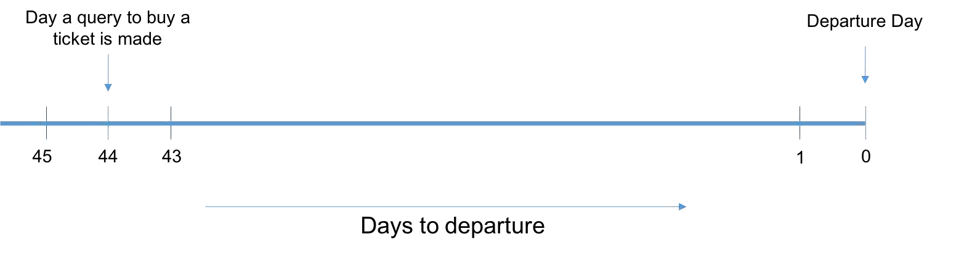

Suppose a user makes a query to buy a flight ticket 44 days in advance, then our system should be able to tell the user whether he should wait for the prices to decrease or he should buy the tickets immediately. For this we have two options:

1. Predict the flight prices for all the days between 44 and 1 and check on which day the price is minimum.
2. Classify the data we already have into, “Buy” or “Wait”. This then becomes a classification problem and we would need to predict only a binary number. However, this does not give a good insight on the number of days to wait.

For the above example, if we choose the first method we would need to make a total of 44 predictions (i.e. run a machine learning algorithm 44 times) for a single query. This also cascades the error per prediction decreasing the accuracy. Hence, the second method seems to be a better way to predict, wait or buy which is a simple binary classification problem. But, in this method, we would need to predict the days to wait using the historic trends.

For this we again have two options:

1. We do the predictions for each flight id. The problem with this is that, if there is a change in flight id by the airline (which happens frequently) or there is an introduction or a new flight for a specific route then our analysis would fail.
2. We group the flight ids according to the airline and the time of departure and do the analysis on each group. For this we need to combine the prices of the airlines lying in that group such that the basic trend in captured.

Moving ahead with the second option, we created the group according to the airlines and the departure time-slot created earlier (Morning, Evening, Night) and calculated the combined flight prices for each group, day of departure and depart day. Since these three are the most influencing factors which determine the flight prices. Also, we calculated the average number of flights that operated in a particular group, since competition could also play a role in determining the fare.

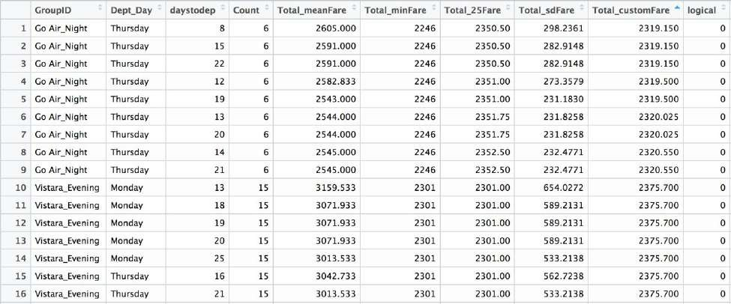

Table 1: Collected data [1]

Combining fare for the flights in one group:

1. Mean fare: This is the average of the fare of all the flights in a particular group corresponding to departure day and days to departure. Because of high standard deviation, taking the mean is not a very good option.
2. Minimum fare: This does not give a very good insight of the trend, as a minimum value could occur because of some offer by an airline.
3. First Quartile: This is a good measure as we are focusing on minimizing the fare and we do not want to consider the flights with high fares.
4. Custom Fare: This is the fare giving more weightage to recent price trend.

Total_customFare = w*(First Quartile for entire time period) + (1-w)*(First quartile of last x days) 5. (We have considered: w = 0.7 and x = & days)

Calculating whether to buy or wait for the this data:

Logical = 1 if for any d < D the Total_customFare is less than the current Total_customFare

(Here, d is the days to departure and D is the days to departure for the current row.)

❏ Calculating the number of days to wait

After creating the train file, we shift to create another dataset which is used to predict number of days to wait. For this, we used trend analysis on the original dataset.

Determining the minimum CustomFare for a particular pair of Departure Day and Days to Departure

We input the train dataset that has been created and find the minimum of the CustomFare corresponding to each combination of Departure Date and Days to Departure. Now with the obtained minimum CustomFare

corresponding to each pair, we do a merge with our initial dataset and find out the Airline corresponding to which the minimum CustomFare is being obtained.

The count on the number of times a particular Airline appears corresponding to the minimum Custom Fare is the probability with which the Airline would be likely to offer a lower price in the future. This probability of each Airline for having a minimum Fare in the future is exported to the test dataset and

merged with the same while the dataset of minimum Fares is retained for the preparation of bins to analyse the time to wait before the prices reduce

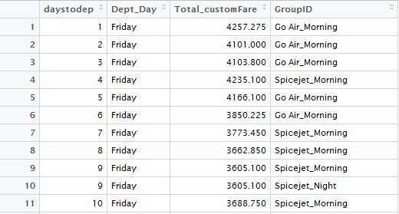

Table 2: Cleaned and prepared dataset[2]

Creation of Bins

We next wanted to determine the trend of “lowest” airline prices over the data we were training upon. So the entire sequence of 45 days to departure was divided into bins of 5 days. In intervals of 5 (this is made dynamic), the first bin would represent days 1-5, the second represents 6-10 and so on.

Corresponding to each bin, we required a value of the fare that would be optimal for consideration in suggesting a value for the days to wait to the user. Among all the points that lie in a bin, the 25th percentile was determined as the value that would be the possible lowest Fare corresponding to the bin which indicates days to departure.

Comparing the present price on the day the query was made with the prices of each of the bin, a suggestion is made corresponding to the maximum percentage of savings that can be done by waiting for that time period. The approximate time to wait for the prices to decrease and the corresponding savings that could be made is returned to the user.

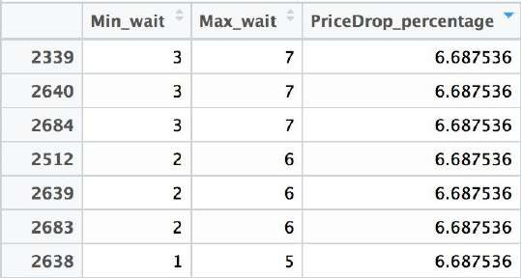

Table 3: Output

**Chapter-4**

**System Analysis & Design**

# 4.1 Database Design

# 

# Figure 2 : Database Design

# 

# 4.2 Use Case Diagram

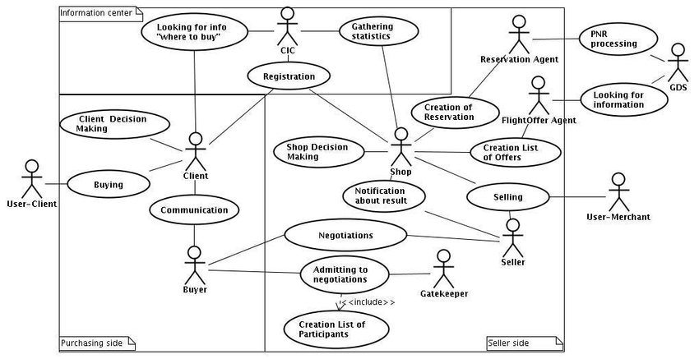

# Figure 3: Use Case Diagram

# 4.3 Activity Diagram

# 

# Figure 4: Activity Diagram

**Chapter-5**

**Result**

# 5.1 Results

❏ In detailed analysis for the Delhi - Guwahati Route

The trends in the data collected for the sector of Delhi to Guwahati busted some of the very famous myths assumed by travellers of the aviation industry.

1. Flight prices do not increase continuously as the Date of Departure approaches closer.

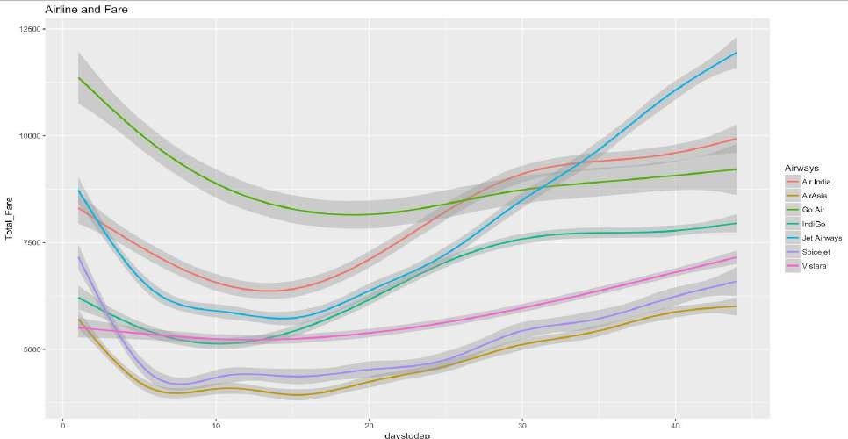

Figure 5 : Flight Price vs Days to Departure

With the validation of the problem statement and with a scope to predict when to buy and when to wait, we begin the analysis of the dataset.

The dataset of the flight prices follows a Lognormal distribution with some outliers which have been ignored as we are only interested with the minimum fare corresponding to a certain route.

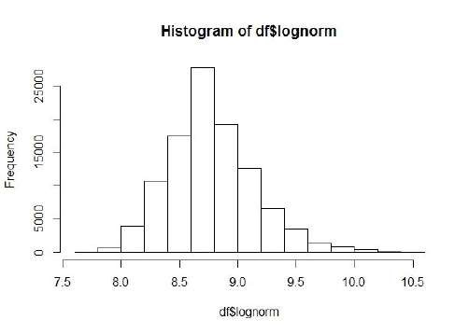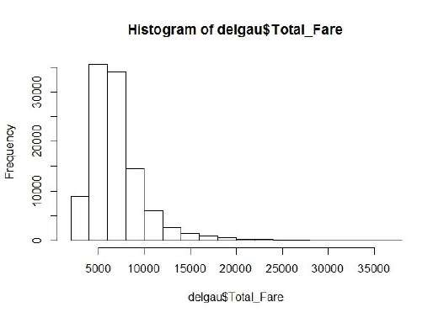

Figure 6 : Distributions before and after transformation

Statistically, the data transformed into lognormal distribution showed a significance level of 1, with skewness and kurtosis falling within the acceptable range for it to be considered a valid transformation.

Further, the trend of all airlines have been customly combined to form a trend used in the prediction of the model. The trend is significantly different for each day and thus different combined trends have been formulated corresponding to the day of the week.

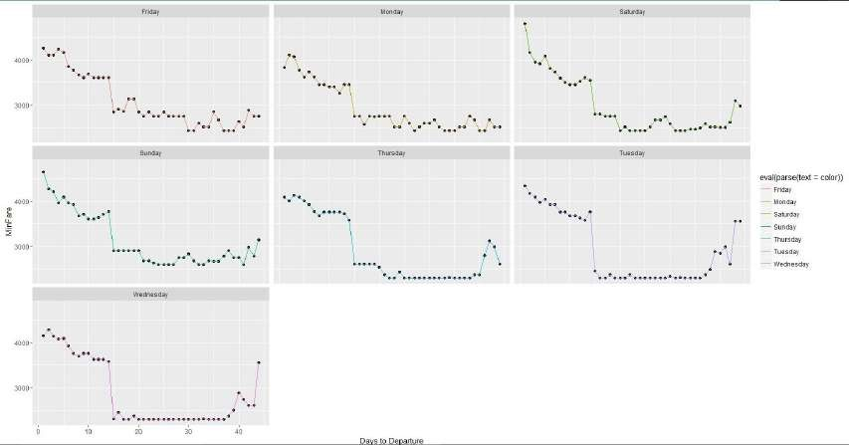

Figure 7 : Combined trends of all airlines for each day of the Week

We performed the prediction using some basic machine learning algorithms to find a benchmark model and the results of the same are shown below for the route of Delhi - Guwahati.

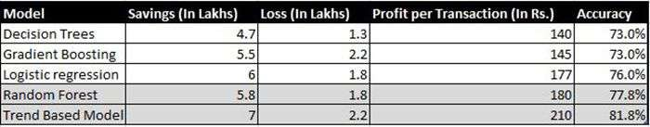

Figure 8 : Comparison between Models

❏ Results for all Routes

In continuation, we developed a custom algorithm for the very specific task which was an amalgamation of the ensemble models and the statistical model as discussed above.

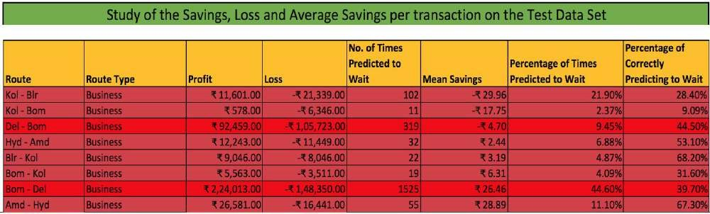

Figure 9 : Analysis on Various Business Routes

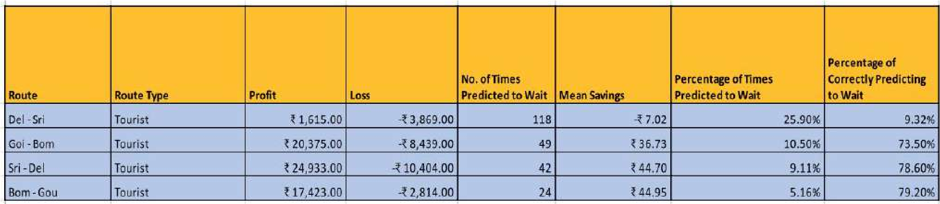

Figure 10 : Analysis on Various Tourist Routes

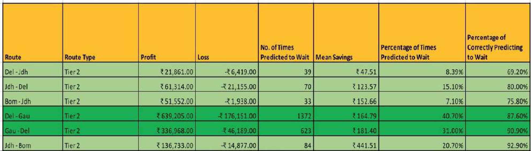

Figure 11 : Analysis on Various Tier-2 Routes

## Conclusion Remarks from Exploratory Data Analysis

From the data collected and through exploratory data analysis, we can determine the following:

* The trend of flight prices vary over various months and across the holiday.

* There are two groups of airlines: the economical group and the luxurious group. Spicejet, AirAsia, IndiGo, Go Air are in the economical class, whereas Jet Airways and Air India in the other. Vistara has a more spread out trend.

* The airfare varies depending on the time of departure, making timeslot used in analysis is an important parameter.

* The airfare increases during a holiday season. In our time period, during Diwali the fare remained high for all the values of days to departure. We have considered holiday season as a parameter which helped in increasing the accuracy.

* Airfare varies according to the day of the week of travel. It is higher for weekends and Monday and slightly lower for the other days.

* There are a few times when an offer is run by an airline because of which the prices drop suddenly. These are difficult to incorporate in our mathematical models, and hence lead to error.

* Along the business routes, we find that the price of flights increases or remains constant as the days to departure decreases. This is because of the high frequency of the flights, high demand and also could be due to heavy competition.

* Only about 8-10% of the times, a person should wait according to the data collected across the Mumbai-Delhi route, compared to 30-40% in Delhi-Guwahati route.

**Chapter-6**

**Conclusion**

## 6.1 Conclusion

From our detailed analysis of each of the 18 routes, we can determine the following

* Flight prices almost always remain constant or increase between the major cities

* Tourist routes and routes that offer services involving Tier-2 cities of the country have uneven trends related to the increase and decrease of airline ticket prices.

* The model in the worst case almost breaks even with the profits and losses, and most case saves an average of about Rs. 200 per transaction when predicting to wait.

* Routes with data collected over the longer duration of time tend to facilitate with much more accurate predictions in the model and thus lead to higher average savings.

We were successfully able to analyse each route and generalize the entire project based in terms of the sector to which the route belonged, and classified them into three major subsections - Business Routes, Tourist Routes and Tier-2 Routes.

We have also successfully busted some of the typical myths and misconceptions related to the airline industry and backed them up with data and analysis.

Finally, we have created a User Interface for the entire process of buying an airline ticket and given a proof of our predictions based on the previous trends with our prediction. Thus leaving it as a battle between ‘**The risk appetite of the user**​ ’ vs ‘​ **Our understanding of the airline**​  **industry**’.​

**Future Work**

* More routes can be added and the same analysis can be expanded to major airports and travel routes in India.
* The analysis can be done by increasing the data points and increasing the historical data used.

That will train the model better giving better accuracies and more savings.

* More rules can be added in the Rule based learning based on our understanding of the industry, also incorporating the offer periods given by the airlines.
* Developing a more user friendly interface for various routes giving more flexibility to the users.

## Competing Interests

We declare that we have no significant competing financial, professional or personal interests that might have influenced the performance or presentation of the work described in this manuscript.

## Author’s Contribution

The work is a product of the intellectual environment of the whole team; and that all members have contributed in various degrees to the analytical methods used, to the research concept, and to the experiment design along with writing the manuscript.

## Acknowledgment

We would like to take this opportunity to express our profound gratitude and deep regard to Dr. Ratnesh Litoriya, for his exemplary guidance, valuable feedback and constant encouragement throughout the duration of the project. His valuable suggestions were of immense help throughout our project work. His perceptive criticism kept us working to make this project in a much better way. Working under him was an extremely knowledgeable experience for us.

## Declaration

We hereby declare that the research paper titled “*Predicting Flight Prices*​ ​” submitted by us is based on actual and original work carried out by us. Any reference to work done by any other person or institution or any material obtained from other sources have been duly cited and referenced. We further certify that the research paper has not been published or submitted for publication anywhere else.

**References**

1. O. Etzioni, R. Tuchinda, C. A. Knoblock, and A. Yates. To buy or not to buy: mining airfare data to minimize ticket purchase price.
2. Manolis Papadakis. Predicting Airfare Prices.
3. Groves and Gini, 2011. A Regression Model For Predicting Optimal Purchase Timing For Airline Tickets.
4. Modeling of United States Airline Fares – Using the Official Airline Guide (OAG) and Airline Origin and Destination Survey (DB1B), Krishna Rama-Murthy, 2006.
5. B. S. Everitt: *The Cambridge Dictionary of Statistics*​ ​, Cambridge University Press, Cambridge (3rd edition, 2006). ISBN 0-521-69027-7.
6. Bishop: *Pattern Recognition and Machine Learning*​ ​, Springer, ISBN 0-387-31073-8.
7. E. Bachis and C. A. Piga. Low-cost airlines and online price dispersion. International Journal of Industrial Organization, In Press, Corrected Proof, 2011.
8. P. P. Belobaba. Airline yield management. an overview of seat inventory control. Transportation Science, 21(2):63, 1987.
9. Y. Levin, J. McGill, and M. Nediak. Dynamic pricing in the presence of strategic consumers and oligopolistic competition. Management Science, 55(1):32–46, 2009.